Motion and Force in a Gravitational Field
Practise Test Marking Key

- Imagine that two new planets have been discovered in another solar system, call them X and Y. They both have the same radius but planet X has twice the mass of planet Y. On the diagram below, draw in the gravitational fields for each planet. (2 marks)
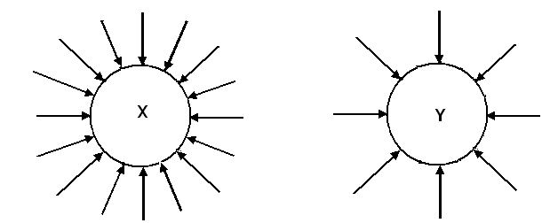
arrow correct direction – [1 mark]
twice the number of arrows on X as Y – [1 mark]

- 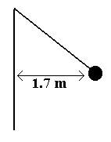A hammer thrower has gradually increased the speed of his hammer so that it completes ten revolution in 22.0 s. The hammer of mass 7.26 kg may be considered to be moving in a horizontal circle of 1.70 m radius. What force is exerted on the hammer thrower’s arm? (4 marks)

10 rev = 22 s  1 rev = 2.2 s  T = 2.2 s  r = 1.70 m  m = 7.26 kg  F_{w} = mg  = 7.26 x 9.8  = 71.148 N  [1 mark] | 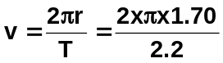  v = 4.8552 ms⁻¹ [1 mark]  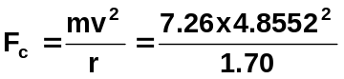  F_{c} = 100.67 N [1 mark]  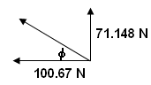  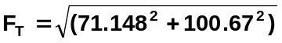  F_{T} = 123.27 N  φ = tan⁻¹ (71.148 ÷ 100.67)  φ = 35.3⁰  F_{T} = 101 N 35.3⁰ above horizontal  [1 mark]

- Discuss one important use for satellites that are evident in our daily lives. (2 marks)
Important use such as:
Various answers such as Communication, Meteorological satellites, TV, etc.

Evident in our lives:
Depends on answer above but a brief discussion on how evident in our lives.
- Ben. whose total mass is 1.20 x 10² kg (Ben and space suit) is on a space walk 725 km above the Earth. Assuming that the force of the nearby space ship is insignificant compared to the force of the Earth,
- What gravitational acceleration does Ben experience on his space walk? (2 marks)

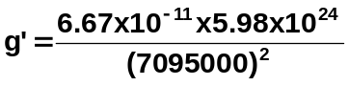m = 120 kg

r = r_{E} + r_{B}
= 6.37 x 10⁶ + 725000 g’ = 7.92 ms⁻² [1 mark]
= 7095000 m [1 mark]
m_{E} = 5.98 x 10²⁴ kg
- What gravitational force is on Ben? (2 marks)
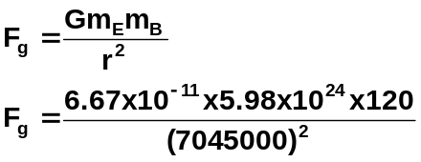

[1 mark]

F_{g} = 951 N [1 mark]

- The mass of Jupiter is 1.90 x 10²⁷ kg and its diameter is 142 984 km. What altitude would a satellite have if its orbital speed is 3.00 x 10⁴ ms⁻¹? (3 marks)
m_{J} = 1.9 x 10²⁷ kg 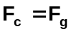
r_{T} = r_{J} + r_{s} 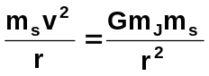 cancel m_{s} and r
v = 3.0 x 10⁴ ms⁻¹ 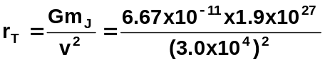 [1 mark]

r_{T} = 140811111 m
r_{s} = r_{T} - r_{J}
= 140811111 – 71492000 [1 mark]
= 69319111

altitude of satellite is 6.93 x 10⁷ m [1 mark]

- A shopkeeper wants to hang two signs from a 10.3 kg horizontal pole fixed to the wall. The first sign has a mass of 5.20 kg and is to be hung 0.800 m from the wall. The second sign has a mass of 6.60 kg and is to be hung 0.200 m from the end of the pole. The pole is 2.00 m in length. If the fixture at the wall can withstand a torque of 2.50 x 10² Nm, will the shopkeeper need to add additional support to the pole? (3 marks)

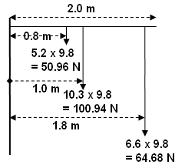

τ = (0.8 x 50.96) + (1.0 x 100.94) + (64.68 x 1.8) [1 mark]
= 40.768 + 100.94 + 116.424
= 258.132 [1 mark]

As the torque is greater than 150 Nm provided, the shopkeeper will need to add additional support.
[1 mark]

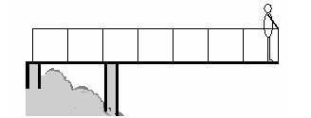
- Alan (mass 85.0 kg) is standing 0.500 m from the end of a 4.60 m viewing platform which extends out over a scenic river. The 2.30 x 10³ kg platform is support by two supports, one at the start of the platform and one 1.60 m from the start as shown. Determine the force on each support. (4 marks)

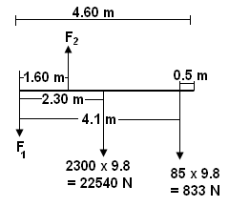
Take moments about F₁
ΣCM = ΣACM
(22540 x 2.3) + (833 x 4.1) = F₂ x 1.6
51842 + 3620.3 = 1.6F₂
55462.3 = 1.6F₂
F₂ = 34664 N

F up = F down
F₂ = F₁ + 22540 + 833
34664 = F₁ + 23373
F₁ = 11291 N

F₁ = 1.13 x 10⁴ N down [2 marks]

F₂ = 3.47 x 10⁴ N up [2 marks]

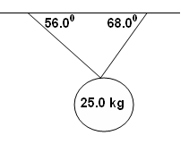
- A mirror ball hangs from the ceiling at a local nightclub. The two supporting wires have angles of 68.0⁰ and 56.0⁰ to the horizontal. The mirror ball has a mass of 25.0 kg. Calculate the tension in each wire including a diagram. (5 marks)

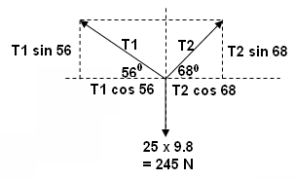

[1 mark]

Horizontal components:

T₁ cos 56 = T₂ cos 68
0.5592T₁ = 0.3746T₂
T₂ = 1.4927T₁ [1 mark]

Vertical components:

T₁ sin 56 + T₂ sin 68 = 245
but T₂ = 1.4927T₁
so
T₁ sin 56 + (1.4927T₁)sin 68 = 245 [1 mark]
0.829T₁ + 1.384T₁ = 245
2.213T₁ = 245
T₁ = 111 N [1 mark]

Resolve for T₂:

T₂ = 1.4927T₁
T₂ = 1.4927 x 110.7
= 165 N [1 mark]

T₁ = 111 N and T₂ = 165 N
- Young Johnny and his brother Sam are playing a new game. Johnny rolls a large ball bearing along the top of a table with a constant velocity of 2.54 ms⁻¹ while his brother pushes a small trolley along the ground below. The idea of the game is to get the ball bearing to land in the trolley after leaving the table. This occurs when the trolley and ball are in the position shown and the trolley is released 0.83 m away from where it will catch the ball bearing. Calculate the height of the table. (4 marks)

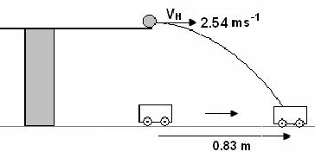
The time for both events to occur will be the same

u_{H} = 2.54 ms⁻¹
s_{H} = 0.830 m
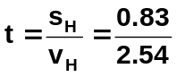
[1 mark]

t = 0.32677 s [1 mark]

s_{v} = ? s_{v} = u_{v}t + ½ gt²
g = 9.8 ms⁻² = 0 + (4.9 x 0.32677²) [1 mark]
t = 0.72047 s = 0.523 m
u_{v} = 0 ms⁻¹
so the table is 0.523 m high. [1 mark]

- The following shows a beach ball thrown a long distance from one person to another without air resistance.
  - If there were air resistance, and the two people didn’t move, would the second still catch the beach ball? NO [1 mark]
  - Draw the possible path of the beach ball with air resistance to justify your answer. (1 mark)
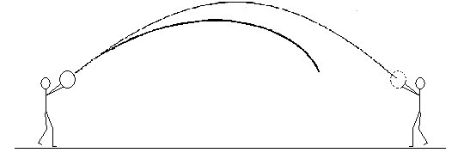

[1 mark]

